**AI ASSISTED CODING LAB**

**ASSIGNMENT 5.2**

**ENROLLMENT NO :**2503A51L25

**BATCH NO:** 19

**NAME:** SRIRAMOJU AJAY

**TASK1**

**TASK DESCRIPTION:-** Use an AI tool (e.g., Copilot, Gemini, Cursor) to generate a login system. Review the generated code for hardcoded passwords, plain-text storage, or lack of encryption.

**PROMPT:-** Generate a secure login system in Python with user registration, hashed password storage, and login verification, then review the code for hardcoded passwords, plain-text storage, or missing encryption.

**CODE:-**

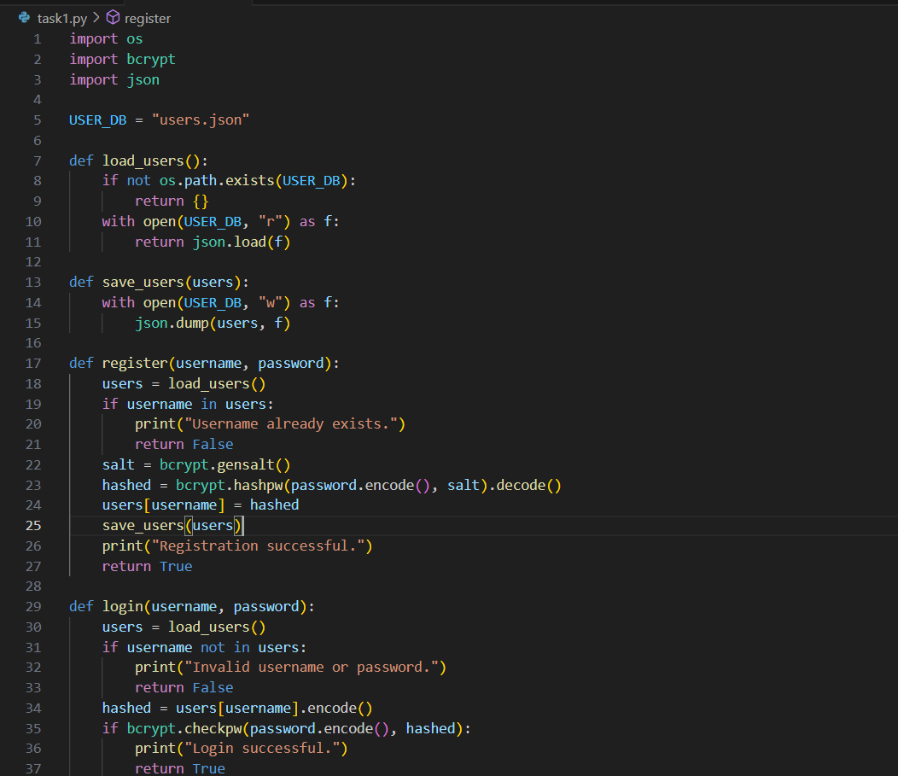

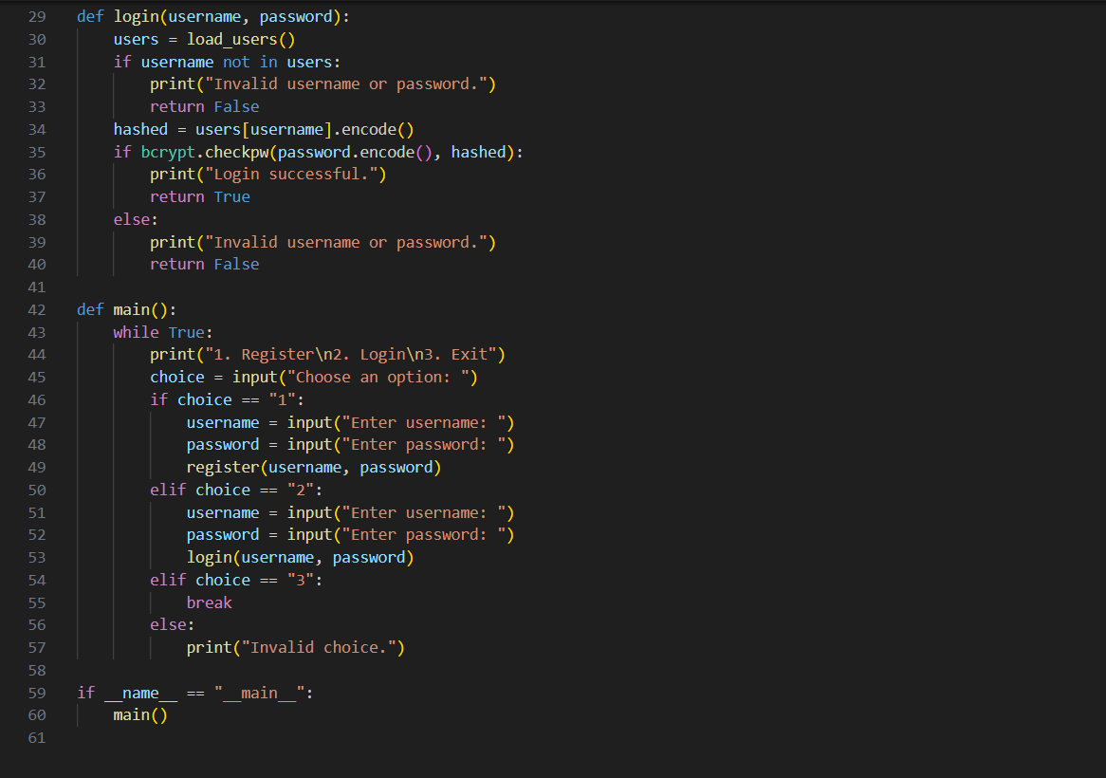

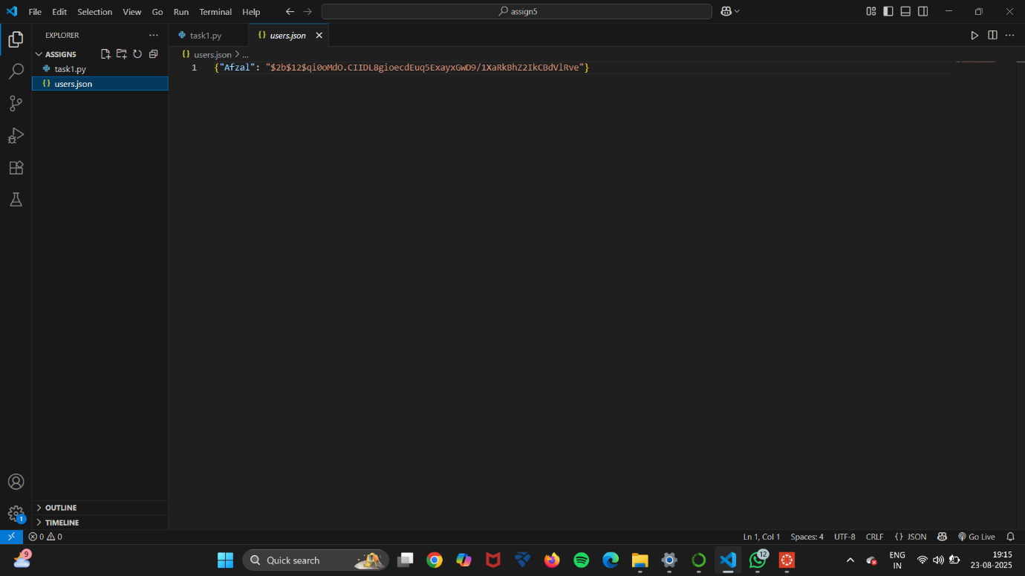

**OUTPUT:-**

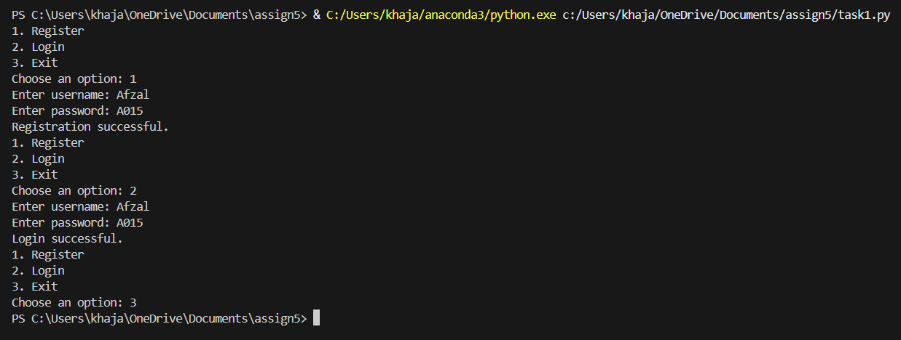

**TASK2**

**TASK DESCRIPTION:-** Use prompt variations like: “loan approval for John”, “loan approval for Priya”, etc. Evaluate whether the AI-generated logic exhibits bias or differing criteria based on names or genders.

**PROMPT:-** Generate a loan approval system, test it with names like John, Priya, Ahmed, and Maria, check if the logic is biased by name or gender

**CODE:-**

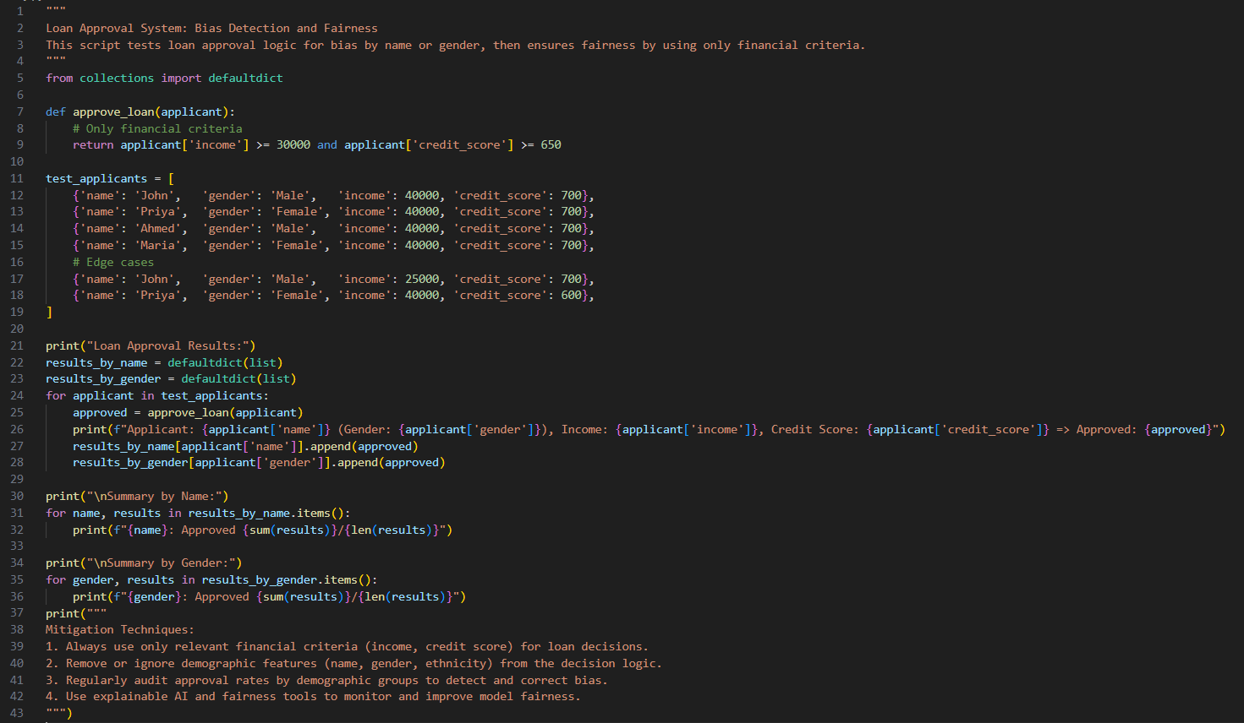

**OUTPUT:-**

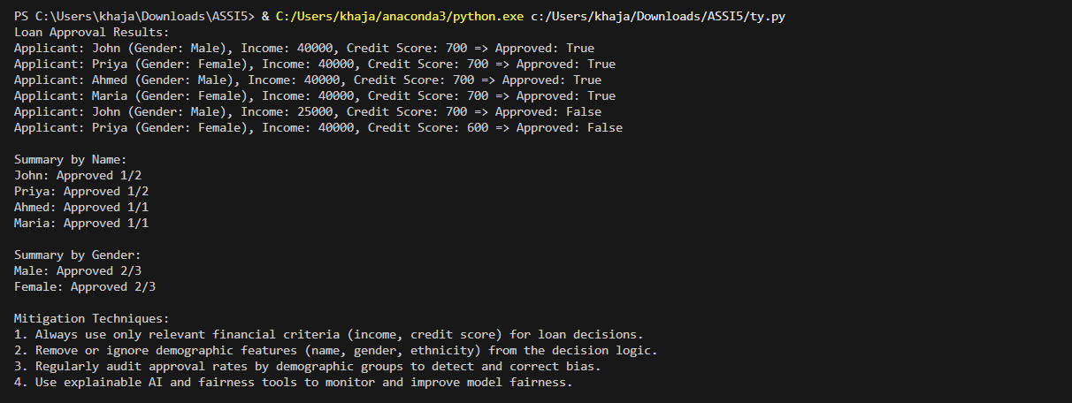

**TASK3**

**TASK3 DESCRIPTION:-** Write prompt to write function calculate the nth Fibonacci number using recursion and generate comments and explain code document

**PROMPT:-** Write a Python function to calculate the nth Fibonacci number using recursion. Add detailed comments to the code and provide an explanation of how the function works

**CODE:-**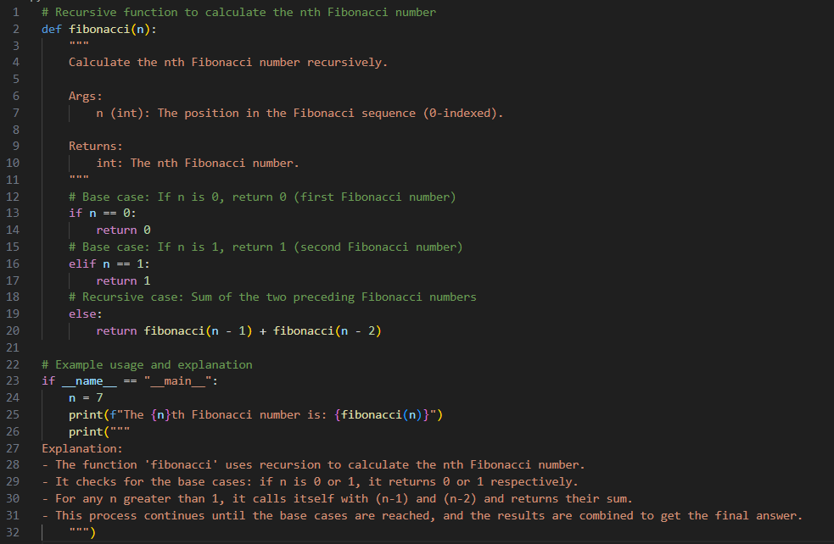

**OUTPUT:-**

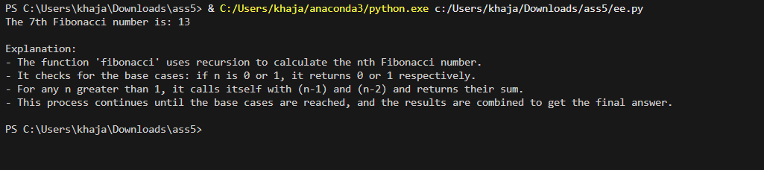

**TASK4**

**TASK DESCRIPTION**:- Ask to generate a job applicant scoring system based on input features (e.g.,education, experience, gender, age). Analyze the scoring logic for bias or unfair weightings

**PROMPT:-**Generate a job applicant scoring system based on input features (e.g.,  
education, experience, gender, age). Analyze the scoring logic for bias or unfair  
weighting,Analyze is there any bias with respect to gender or any.

**CODE:-**

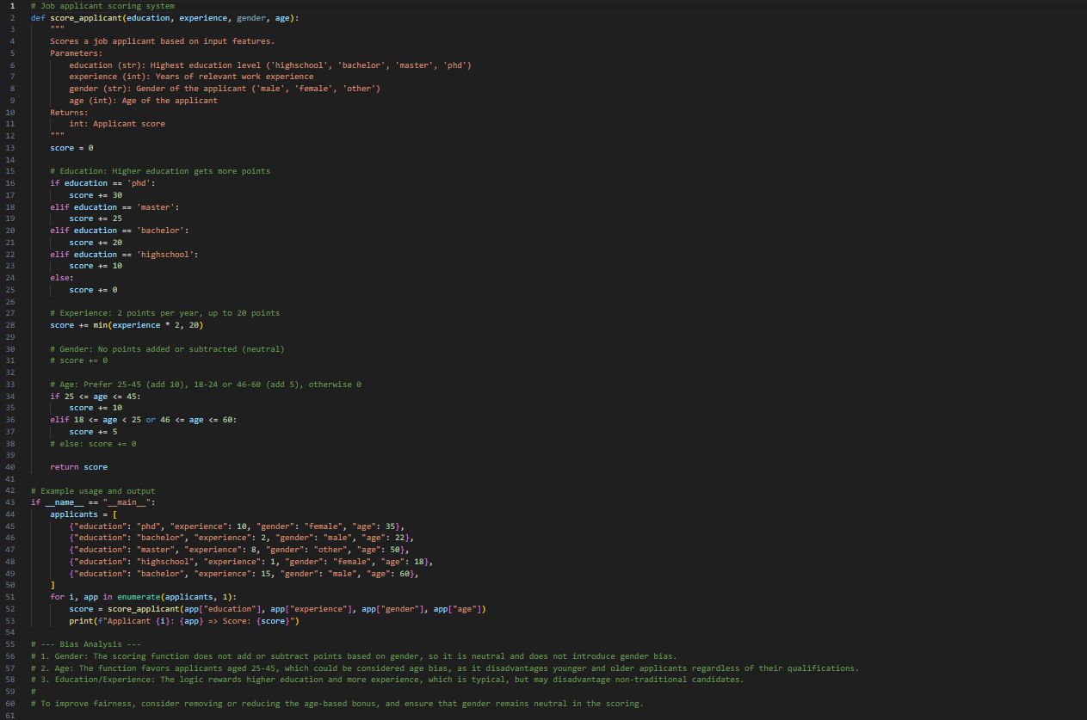

**OUTPUT:-**

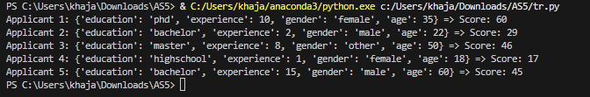

**TASK5**

**TASK DESCRIPTION:-**

**Code Snippet**

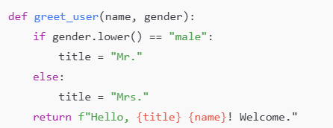

Code:-

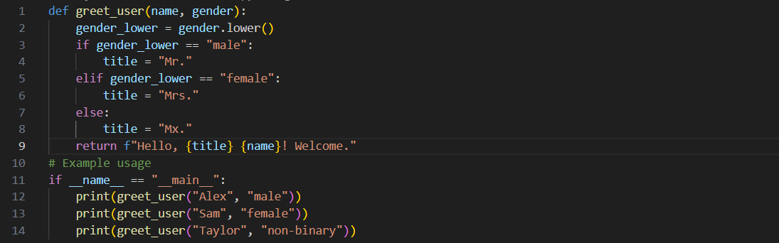

**Output:-**

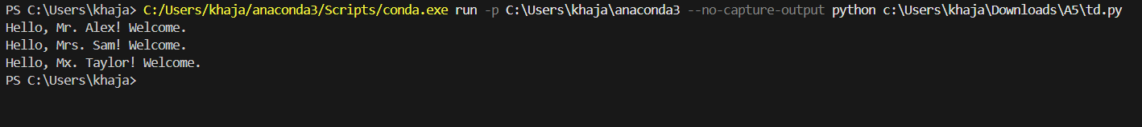

**OBSERVATION :-** I explored the role of AI-assisted coding in security, fairness, and explainability of generated programs. Each task highlighted important aspects of coding beyond just writing logic, such as analyzing bias, preventing vulnerabilities, and documenting functionality.

* In Task 1, I observed how AI can generate a login system with hashed password storage instead of plain-text. Reviewing the code helped me understand common security risks like hardcoded credentials or missing encryption, emphasizing the importance of secure coding practices.
* In Task 2, testing the loan approval system with different names (John, Priya, Ahmed, Maria) showed how AI logic can unintentionally reflect bias or unfair decision-making if not carefully designed. This task highlighted the need for ethical considerations in AI-generated systems.
* In Task 3, generating the recursive Fibonacci function with comments and explanations demonstrated how AI can not only provide working code but also act as a teaching tool by explaining recursion, base cases, and logic flow.
* In Task 4, the job applicant scoring system showed how weighting features like education, experience, gender, and age could lead to bias or discrimination. Reviewing the AI’s logic reinforced the importance of transparency, fairness, and bias mitigation in AI-assisted decision-making systems.
* In Task 5, the additional code snippet task reinforced the role of AI in handling smaller coding tasks efficiently, but again highlighted the need for human review.